**-22AIE442-  
Robotics operating systems and robotic simulations**

# Swarm Robotics for Efficient Pathfinding in Constrained Warehouses

## **Team Details**

**Team : 10**

|  |  |
| --- | --- |
| **Name** | **Registration Number** |
| Girish S | AM.EN.U4AIE22044 |
| Ashwin Sasi | AM.EN.U4AIE22007 |
| Nandana | AM.EN.U4AIE22034 |
| Harishankar Binu Nair | AM.EN.U4AIE22023 |

# 

# 

## **Problem Introduction**

Warehouse operations often require high-speed, efficient movement of goods within limited spaces. Traditional systems face limitations in these environments, especially when dealing with narrow aisles and high congestion. Introducing swarm robotics in these scenarios offers a potential solution by distributing tasks among multiple robots that work collectively. However, managing multi-agent pathfinding (MAPF) and conflict-free route planning becomes challenging, as robots must avoid collisions, prevent deadlock situations, and navigate dynamically changing paths. Achieving smooth, coordinated movement through complex paths in a constrained environment is essential to enhancing warehouse productivity.

## **Project Proposal**

This project aims to develop a swarm robotics system capable of moving goods efficiently within a constrained warehouse environment. By leveraging multi-agent pathfinding and sophisticated route planning algorithms, we aim to overcome challenges in coordinating multiple robots in real-time to avoid traffic congestion and optimize route efficiency. The proposed prototype will simulate a warehouse with robots performing pickup and drop-off tasks in a structured yet restricted space. We’ll focus on designing algorithms that prioritize collision avoidance, adaptability, and resource utilization to create a scalable and robust solution for real-world applications.

## **Objective of the Project**

The primary objective is to design and test a swarm robotic system capable of efficient, conflict-free navigation in constrained environments. Specifically, we aim to:

1. Develop a system that allows robots to move goods across narrow aisles with minimal delays.
2. Create multi-agent pathfinding algorithms that optimize routes and prevent traffic conflicts.
3. Test the system in simulated and real environments to evaluate performance in terms of route optimization, navigation accuracy, and congestion management.

## **Prototype Draft**

The prototype will consist of a scaled-down warehouse environment featuring three pickup depots and three drop-off depots. Robots will be tasked with navigating narrow aisles to move goods from pickup to drop-off points, demonstrating efficient pathfinding and traffic avoidance in real time. The setup will include:

* **Simulated environment testing:** Initial testing within a digital simulation to fine-tune algorithms and map out optimal pathfinding.
* **Physical test environment:** Deploying small robots in a physical test space with predefined depots and aisles, focusing on route optimization, real-time navigation, and traffic avoidance mechanisms.

## **Scope of the Project**

The project will encompass the following:

1. **Designing MAPF and route planning algorithms** that ensure efficient, conflict-free navigation for multiple robots.
2. **Implementing the prototype in both simulated and physical environments,** with a focus on observing and analyzing robot behavior in constrained spaces.
3. **Evaluating the system’s performance** based on parameters like route efficiency, traffic avoidance, and adaptability in changing environments.
4. **Exploring scalability potential** for larger warehouse environments, with a roadmap for expanding the project to include more robots and complex routes.

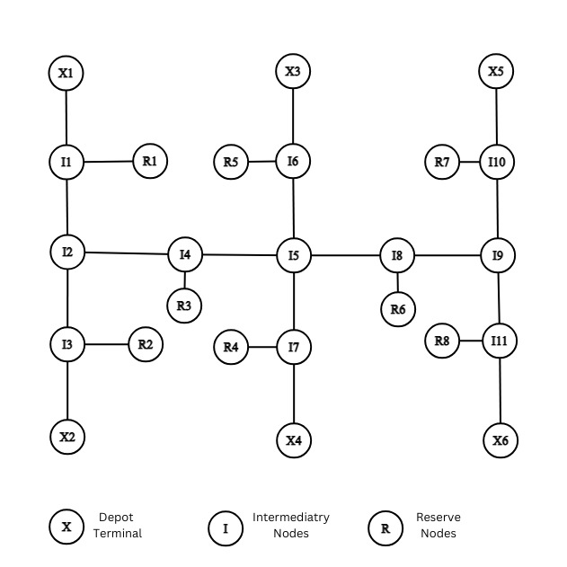

Fig. 1: An example environment for MAPF and routing graph, the reserve nodes are used for solving conflicts in routing